How to delete DB

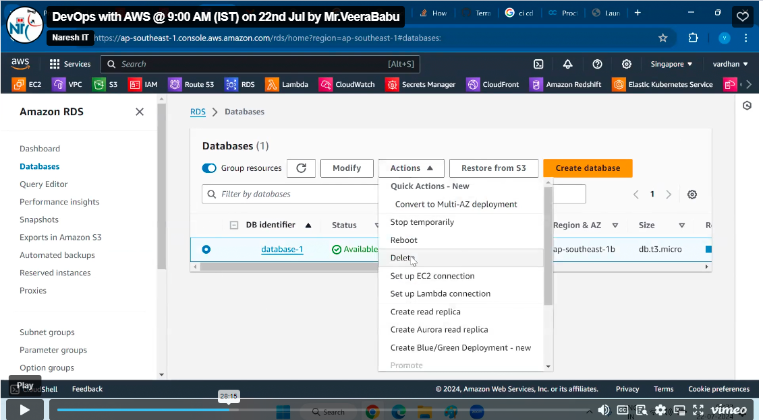

Un check create final snapshot

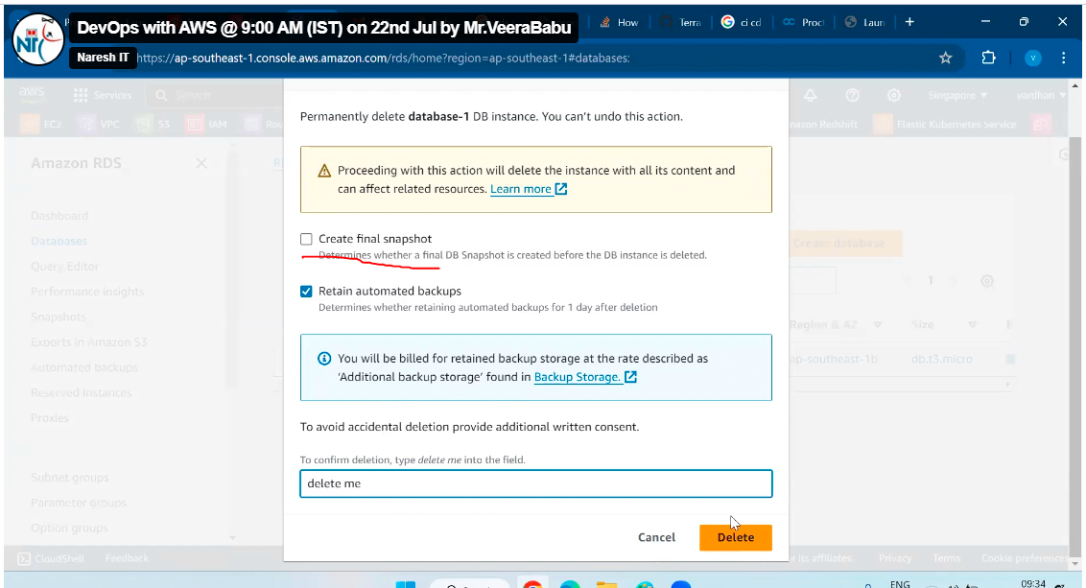

Here we can promote read replica as the master ,when your DB down.

After creating DB if you forget the password the click on modifies and then we can change the password

Query Editor

This is used to connect directly DB without third party tool from this option and we can write a query here only but only Aurora serverless databases that you can access.

If DB is private, we can connect from external like third party tools.

Performance Insights

By using this we can visualize the load of the database on your Amazon RDS, here we can check the performance of the DB

Snapshot

It is nothing but backup

Snapshot type

DB Instance: inside db. there are dev, test, fraud etc. that backup it will take

DB cluster: it is an entire cluster of data base, including read replica also, including configuration also

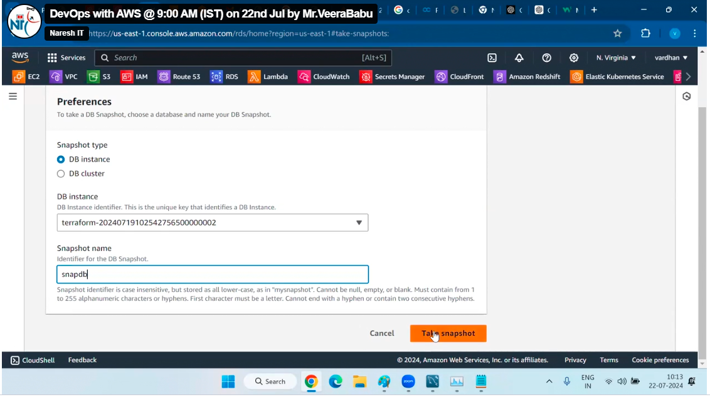

my snapshot is ready now select snapshot we can see

Migrate snapshot (creating a DB at this time)

It is nothing but moving from one place to another, but using this we can change anything while launching

Restore snapshot

It is nothing nut creating database from snapshot (this is like AMI in ec2)

Exports in Amazon S3(2)

You can upload your snapshot into S3 bucket

Automated backups

Once you create RDS, the system will provide automatic backup option.

This we can find while creation of DB in that BACKUP option

